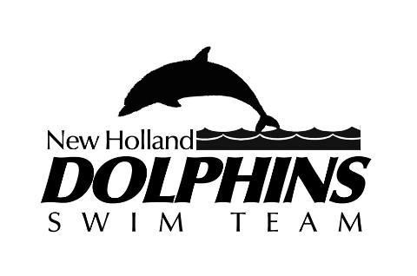
Nondiscrimination Policy

The New Holland Swim Team nonprofit organization is committed to providing an environment that is free from discrimination in opportunity because of race, color, religion, creed, national origin, ancestry, disability, gender or sexual orientation. The Board of Directors has issued the following policy stating the Teams views in this matter:

It is the policy of New Holland Swim Team to:

• Strictly follow personnel procedures that will ensure equal competing opportunity for all swimmers without regard to race, color, religion, creed, national origin, gender, sexual orientation, ancestry, marital status and disability

• Make reasonable accommodations wherever necessary for all parents or swimmers with disabilities, provided that the individual is otherwise qualified to safely perform the duties and assignments connected with the position and provided that any accommodations made do not require significant difficulty or expense.

• Achieve understanding and acceptance of The New Holland Swim Teams policy on equal opportunity to compete by all swimmers from parents and by the communities in which the team competes.

• Thoroughly investigate instances of alleged discrimination and take corrective action if warranted;

• Be continually alert to identify and correct any practices by individuals that are at variance with the intent of the Equal Compete Opportunity Policy.

At this time, The New Holland Dolphins Swim Team would like to reaffirm this policy and call upon all personnel to effectively pursue the policy as stated.

